5.SIMULATION RESULTS
5.1.SimulationDiagram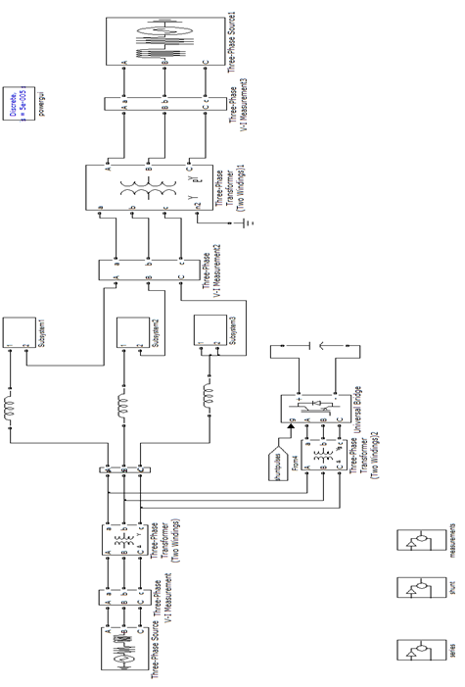

Fig.5.1. simulation diagram of DPFC

5.2. Simulation Results

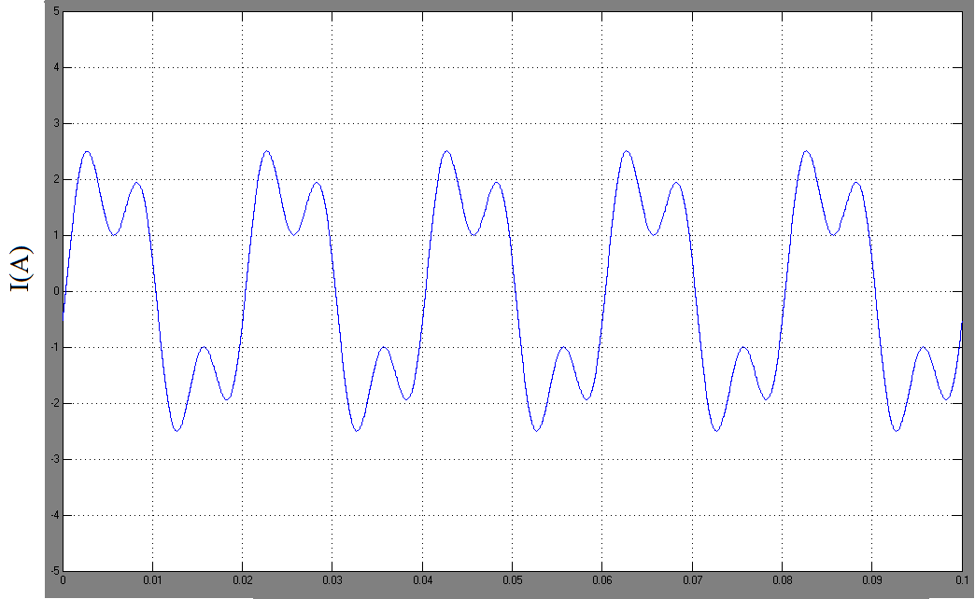
Time (sec)
Fig.5.2. DPFC operation in steady-state: line current

To verify the DPFC principle, two situations are demonstrated the DPFC behavior in steady state and the step response. In steady state, the series converter is controlled to insert a voltage vector with both d- and q-component, which is Vse,d,ref = 0.3 V and Vse,q,ref = −0.1 V.

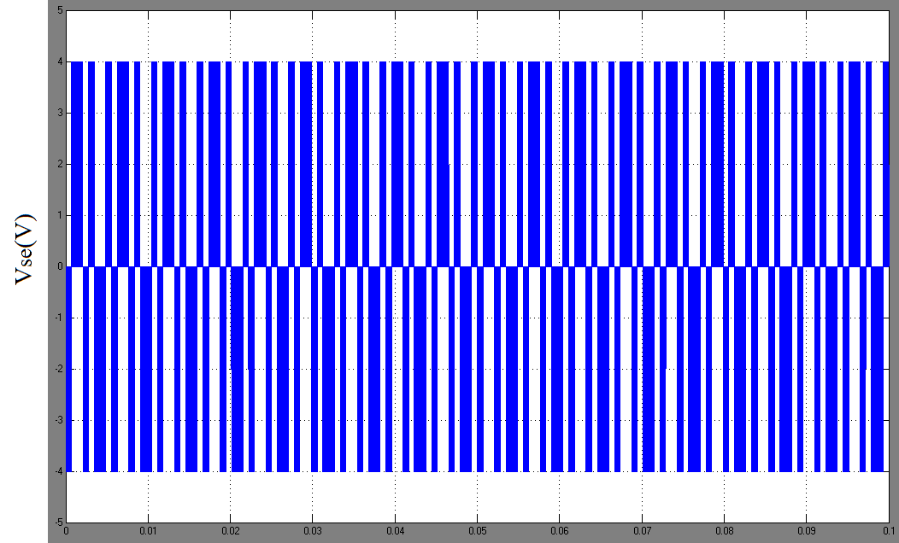
Time (sec)
Fig.5.3. DPFC operation in steady-state: series converter voltage

For clarity, only the waveforms in one phase are shown. The voltage injected by the series converter, the current through the line, and the voltage and current at the Δ side of the transformer are illustrated. The constant third-harmonic current injected by the shunt converter evenly disperses to the 3-phases and is superimposed on the fundamental current. The voltage injected by the series converter also contains two frequency components in Fig.5.3.

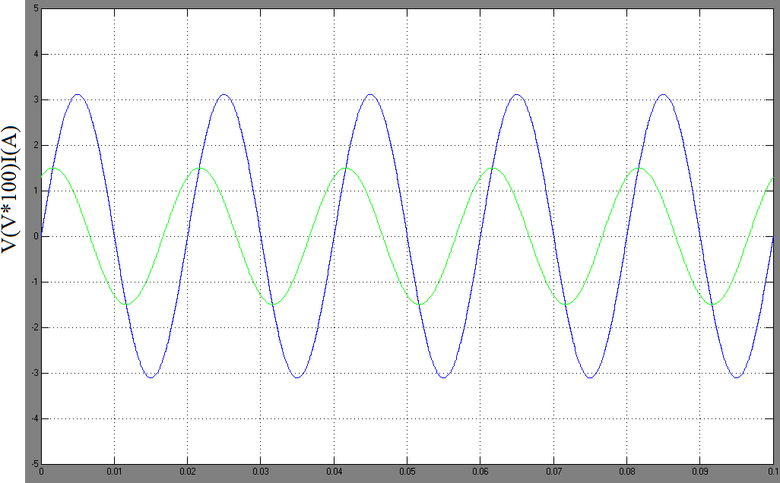
Time (sec)
Fig.5.4. DPFC operation in steady-State: bus voltage and current at the ∆ side of the transformer.

The amplitude of the pulse width modulated waveform represents the dc-capacitor voltage, which is well maintained by the third harmonic component in steady state. As shown, the dc voltage has a small oscillation; however, it does not influence the DPFC control. Demonstrates the third-harmonic filtering by the Y–Δ transformers. There is no third-harmonic current or voltage leaking to the Δ side of the transformer. The fig.5.4 shows that the operation of the bus voltage and current in steady state.

